Holsworthy Public School Communication
Holsworthy Public School uses a variety of ways to communicate information to our parents, students and community members about activities and events. The school website is being updated regularly and is a great opportunity to view the wonderful experiences that are happening at our school.
Website |  | Skoolbag
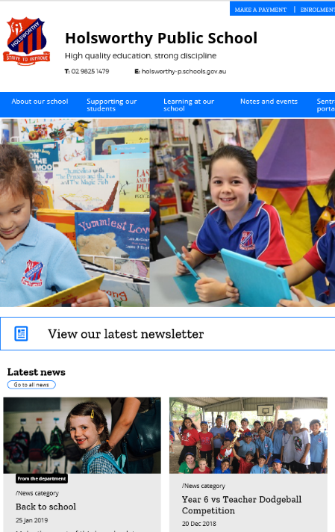  How to access:  Simply search for ‘Holsworthy Public School’ on your internet browser or enter  www.holsworthy-p.schools.nsw.gov.au in your address bar.  Information accessible:  - Home page - latest news, gallery of  events and calendar of upcoming events  - About our school – enrolments, staffing  & policy information  - Supporting our students – information  on caring for students  - Learning at our school – curriculum  activities & the interest groups we offer  - Notes and Events - copies of notes  that can be printed at home  - Contact Us – information to support you  contacting our school |  | 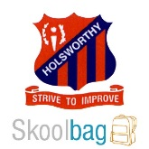  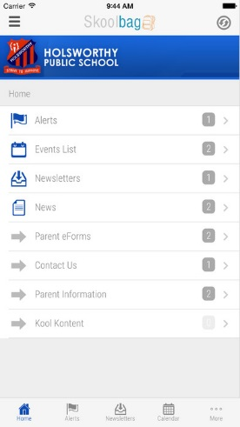  How to install:  Simply search for ‘Holsworthy Public School’ on your phones app store and install.  Information accessible:  - Alerts – important messages and reminders  - Events – details on all the upcoming events at HPS  - Newsletter – added fortnightly (you can sign up  for the email list)  - Notes – copy of notes students have received
Newsletter |  | School Notes
How to access:  - Click the newsletter link on the school website  - View the newsletter section on the Skoolbag App  - Sign up for the ‘newsletter’ email list via Skoolbag – under the eForm section of the app fill out the ‘Newsletter Email Subscription Form’ and submit |  | 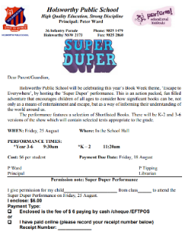  How to access:  - Students receive notes about important information, incursions and excursions through their classroom teacher.  - Notes can also be found on the school website under ‘notes and events’ or viewed under the ‘Notes and Important information’ section on Skoolbag
Contact | If you have any questions please feel free to contact the school by:  Phone: 9825 1479  e-mail: holsworthy-p.school@det.nsw.edu.au

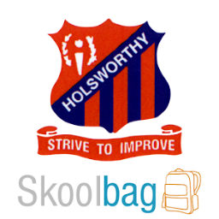
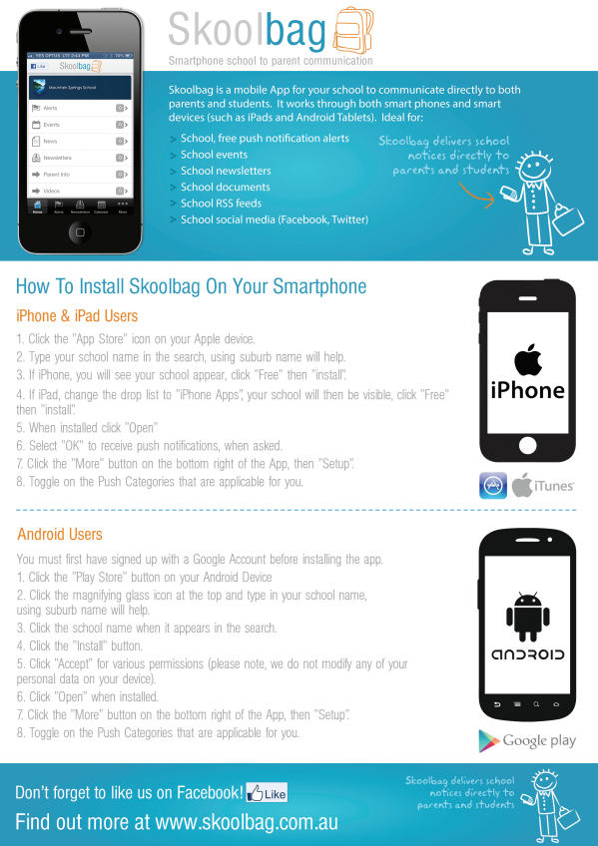
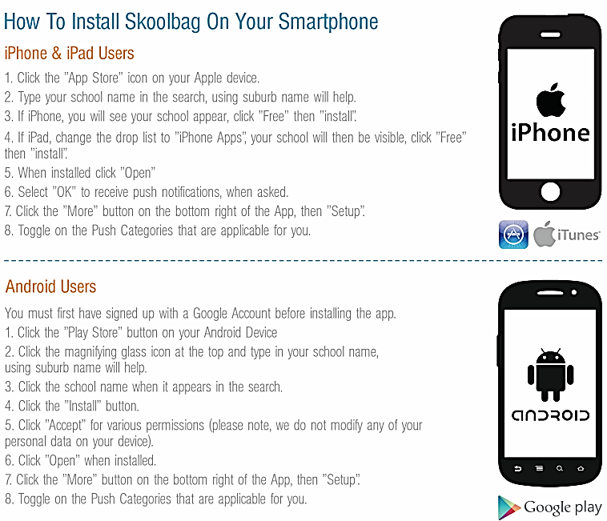
For parents wishing to receive the newsletter via email, please follow these steps:
- Go to the eForm section of the Skoolbag app.
- Select the form called 'Newsletter Email Subscription Form'.
- Complete this with your name and email address.
- You will be asked which mailing list you would like to sign up for. Click on the options and select 'Newsletters'.
- You can then view a summary and submit your completed form.
Email Subscription List

